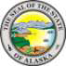 BASIC ARCHIVAL TRAINING 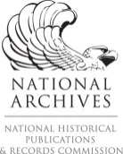
SCHOLARSHIP APPLICATION QUESTIONNAIRE

- Your Name, Institution & Job Title:

- Explain the benefit if you took this training.

- Explain how your institution can better serve its community (city, town, village borough, region) if archival records are properly administered.

- What other job-related training have you taken in the past two years?

- What are your career goals?

- When did you become interested in archives and why are you still interested?

* * * * * * * * * * * * * * * * * * * * * *
Scholarship Deadline is April 24th, 2014
Ten travel scholarships are available up to $1,000 each.
Email completed Questionnaire to State Archivist dean.dawson@alaska.gov.

